[s1,s2,s3]=size(im);

BW=zeros(s1,s2);

Porosity=round(sum(sum(BW))/(s1\*s2)\*100)

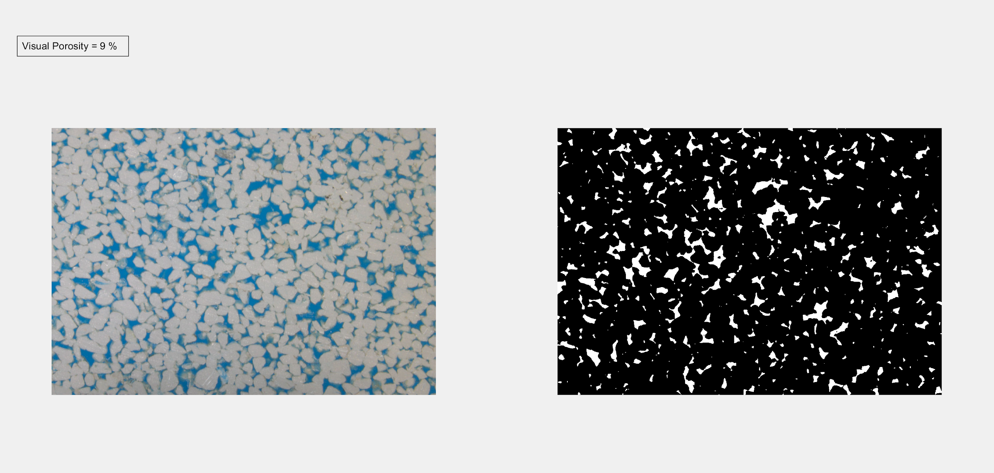

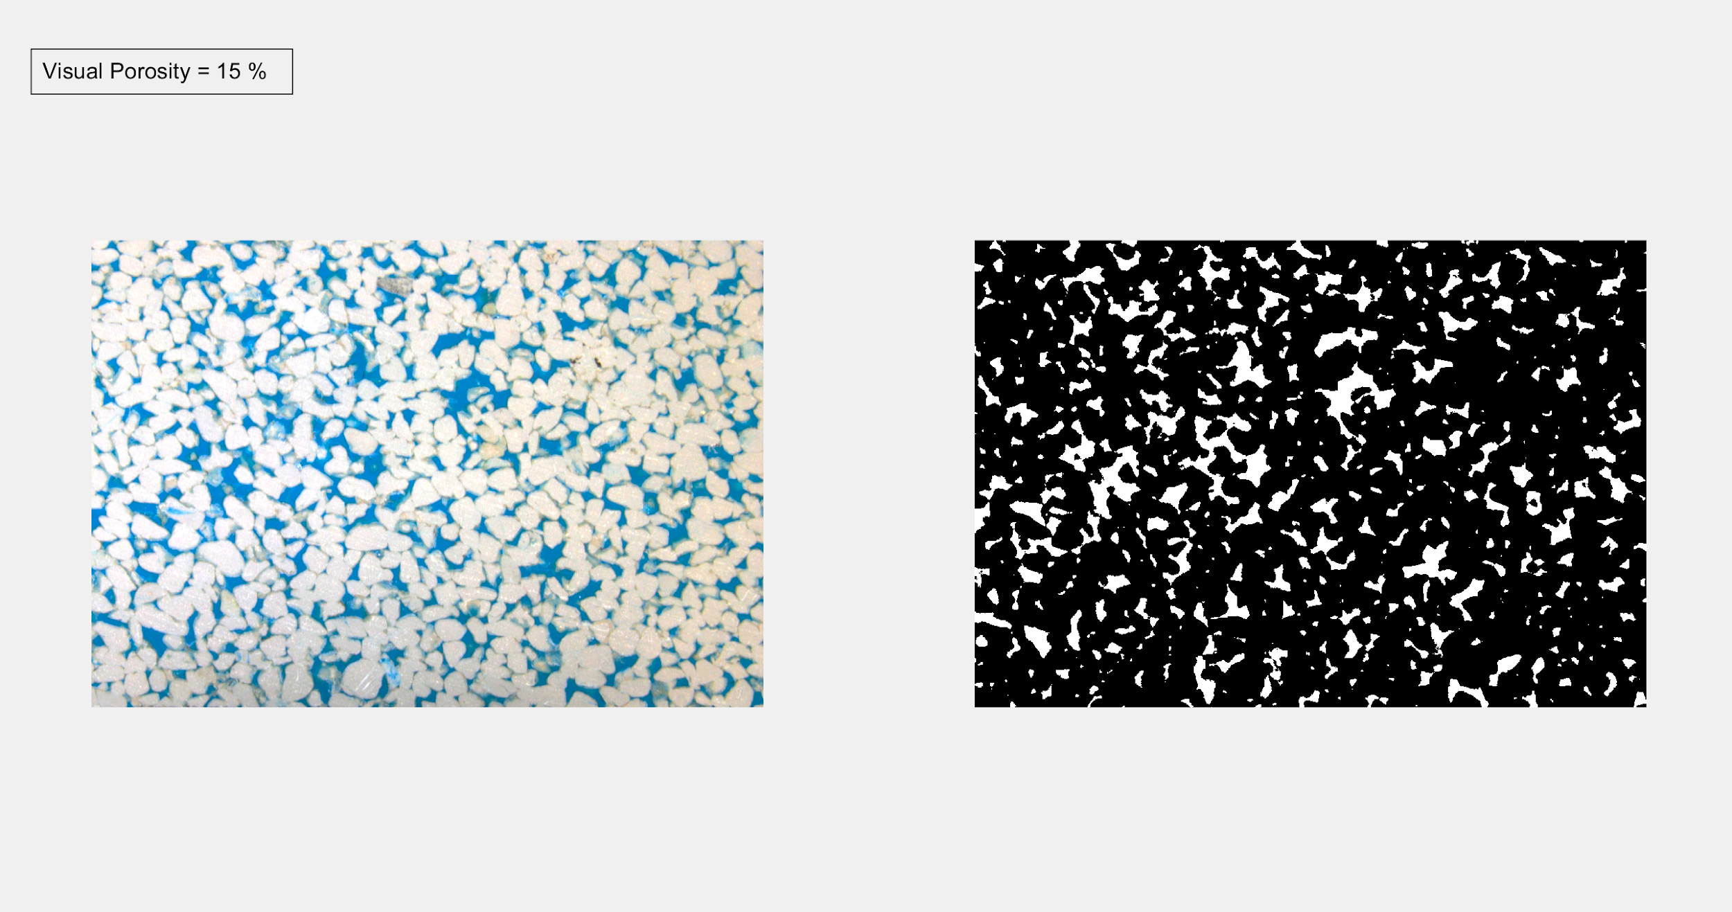

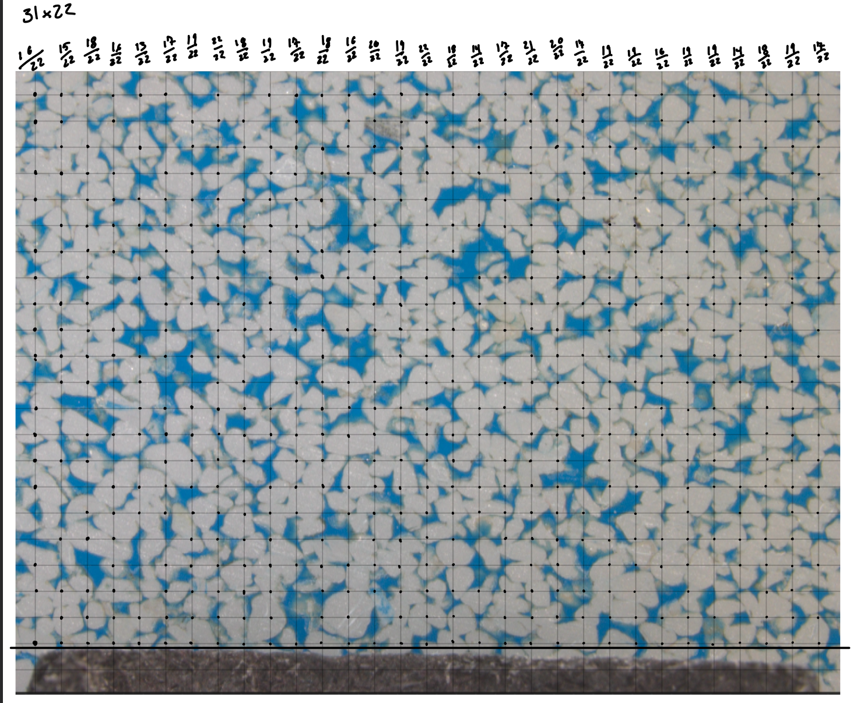

19.06% porosity